**Name of Experiment**: Basic Linux Command.

**Object**: We are want to learn about the basic Linux command with Linux mint operating system.

**Command Statement:**

1. **whoami**: It shows who logged on this system.

Basic syntax: whoami

Output:

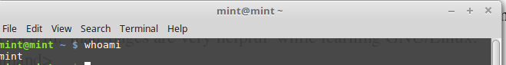

1. **hostname**: It tells on which machine you are.

Basic syntax: hostname

Output:

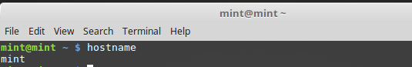

1. **pwd**: It shows the path of current working director.

Basic syntax: pwd

Output:

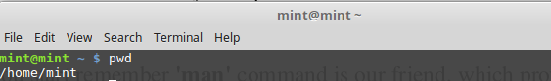

1. **cd** : It brings us to the highest level of your home directory of computer

Basic syntax: cd

Output:

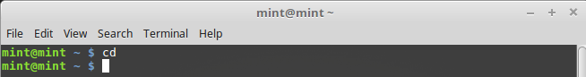

1. **cd**  .. : It moves one directory up.

Basic syntax: cd ..

Output:

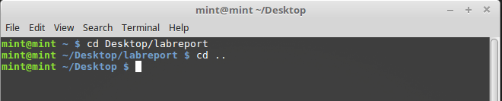

1. **cd ../ ../** : It moves two directories up (and so on)

Basic syntax: cd ../ ../

Output:

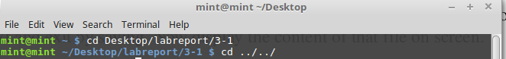

1. **cd <dir_name>** : It switches to 'dir_name' directory

Basic syntax: cd Desktop

Output:

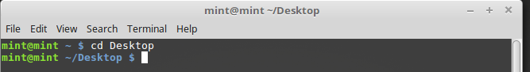

1. **mkdir <dir_name**>:It creates a directory with specified 'dir_name'.

Basic syntax: mkdir labreport

Output:

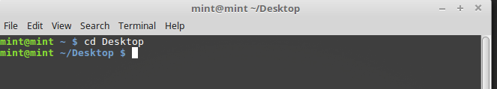

1. **touch**: It creates files.

Basic syntax: touch myfile.txt

Output:

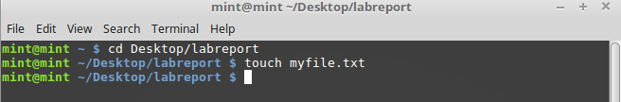

1. **find**: It finds out file from a specific directory.

Basic syntax: find Desktop/labreport/profile.txt

Output:

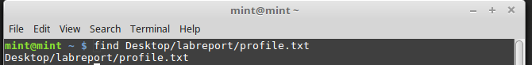

1. **mv <name1> <name2>:** It renames the directories or files.

Basic syntax: mv myfile.txt profile

Output:

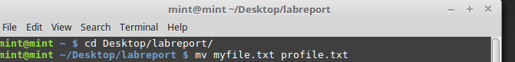

1. **cp <name> <path>** : It copies file/directory as specified in path

Basic syntax: mv myfile.txt profile

Output:

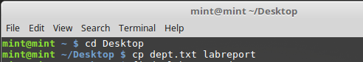

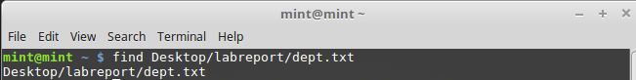

1. **rmdir <dir_name>** : It removes entire directory.

Basic syntax: rmdir Dept

Output:

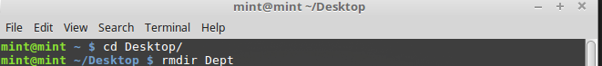

1. **rm <file_name>** : It removes file name.

Basic syntax: rm pi.txt

Output:

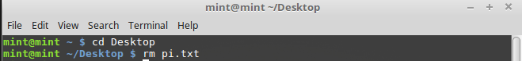

**Conclusion:** we learn about Linux basic command in this lab experiment. It helps us to use Linux operating system easily. We are able to develop future project in Linux operating system more efficiently and effectively.